CPE169P

Module 2 Machine Problem Guide

**Part 1: Practice Exercises**

**Download the files here:** [**Module2_MP1_Files**](https://mymailmapuaedu-my.sharepoint.com/:f:/g/personal/dapadilla_mapua_edu_ph/EpvSjwWA4MREmHxeJed2tKkBZAC6SdLE7q758vkCi5N5rw?e=haGtuX)

1. Using SQLite in Kivy App
2. Make a Mod2_MP1 folder
3. Copy the sqlite_01 folder into the Mod2_MP1 folder
4. Run Visual Studio Code and open the sqlite folder.
5. Run the fetchdata.py. You should have the same output as shown below.

|  |  |
| --- | --- |
|  | |
|  |  |

1. Change the sql statement passed as argument to executeQuery() function with the below statements

|  |  |
| --- | --- |
| Table1: Sample Sqilte Statements | |
| 1 | SELECT InvoiceId, BillingAddress, Total FROM invoices  WHERE Total BETWEEN 14.91 and 18.86 ORDER BY Total; |
| 2 | SELECT albumid, COUNT(trackid) FROM tracks  GROUP BY albumid; |
| 3 | SELECT Title, Name FROM albums  INNER JOIN artists ON artists.ArtistId = albums.ArtistId; |
| 4 | SELECT trackid, name, albumid  FROM tracks WHERE albumid = (  SELECT albumid FROM albums  WHERE title = 'Let There Be Rock' ); |
| 5 | SELECT customerid,  firstname,  lastname  FROM customers  WHERE supportrepid IN (  SELECT employeeid  FROM employees  WHERE country = 'Canada'  ); |

1. Add the **sqlite_02** in the Mod2_MP1 and open the folder in Visual Studio Code.
2. Run the main.py

|  |
| --- |
|  |
|  |
|  |
|  |

1. Try running the other sqlite statements in Table 1. You will be seeing the sample below result.

|  |
| --- |
|  |
|  |
|  |
|  |

1. Remove the ‘BY’ in the ‘GROUP BY’ clause as shown below. You should be seeing the same problem as shown in the below second screengrab.

|  |
| --- |
|  |
|  |
|  |
|  |

1. **Using json**
2. Open in VS Code the **json\01** folder. You will see three files (main.py, weather.json, and manila_weather_2021-04-16.json)
3. Open the main.py and uncomment the ‘part 1: display main’. Use the weather.json file

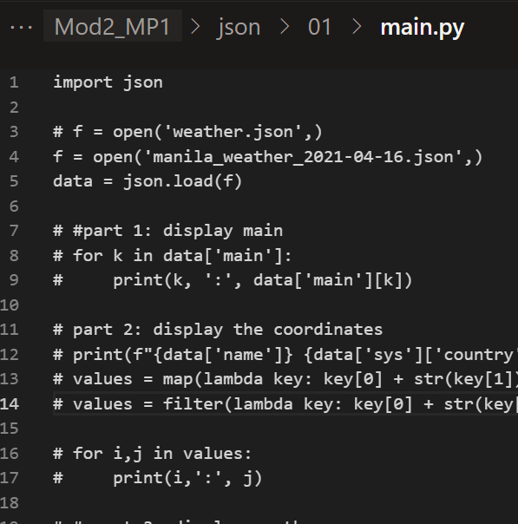

1. After running the main.py, you should have the same below display.

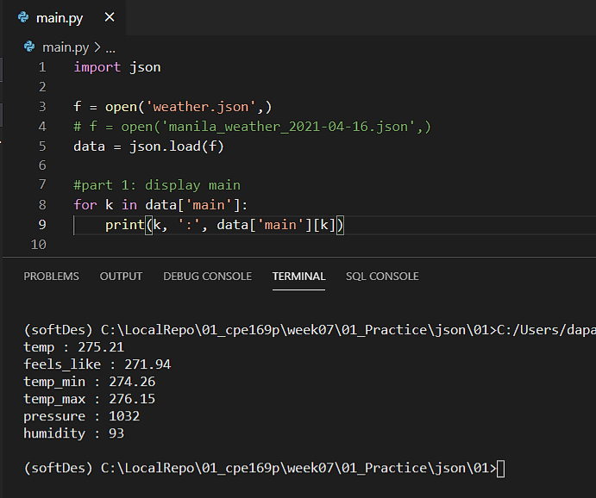

1. Comment ‘part 1’ and uncomment ‘part 2’. Do this also with ‘part 3’. You should have the below display.

|  |
| --- |
|  |
|  |
|  |
|  |

1. Try running steps 11 to 13 using the ‘manila_weather_2021-04-16.json’ file.
2. **Using Kivy JSON store**
3. Open the json/02 folder in VS Code. Run the main.py
4. You will see the same below display. The program will also create the test_1.json file as shown in the below code snippet.

|  |
| --- |
|  |
|  |
|  |
|  |

**Part 2: ToDo Programming Tasks**

Directions: Create a separate folder for each below task (e.g. Mod2_MP1_ToDo_01)

|  |  |
| --- | --- |
| **ToDo Folder Name** | **Description** |
| Mod2_MP1_ToDo_01 | Modify the program in **sqlite_02** folder so that it will display a user-friendly message if the query string is not correct. |
| Mod2_MP1_ToDo_02 | Modify the kivy weather in ____ to display the corresponding icon  Example:  Json file (weather.json) content: "weather":  [{"id":803,"main":"Clouds","description":"broken clouds",**"icon":"04n"**}],  OpenWeather url: **http://openweathermap.org/img/wn/04n@2x.png**    Your Kivy may have the below display |
| Mod2_MP1_ToDo_03 | Make the program (Kivy JSON Store) a Kivy GUI program that has a class that contains methods that will:   1. create the json file (if it does not exist), and 2. A method that will be passed as a callback function in a display button |

**References:**

* [SQLite Tutorial - An Easy Way to Master SQLite Fast](https://www.sqlitetutorial.net/)
* <https://kivy.org/doc/stable/_modules/kivy/uix/boxlayout.html>
* <https://kivy.org/doc/stable/api-kivy.storage.html#module-kivy.storage>